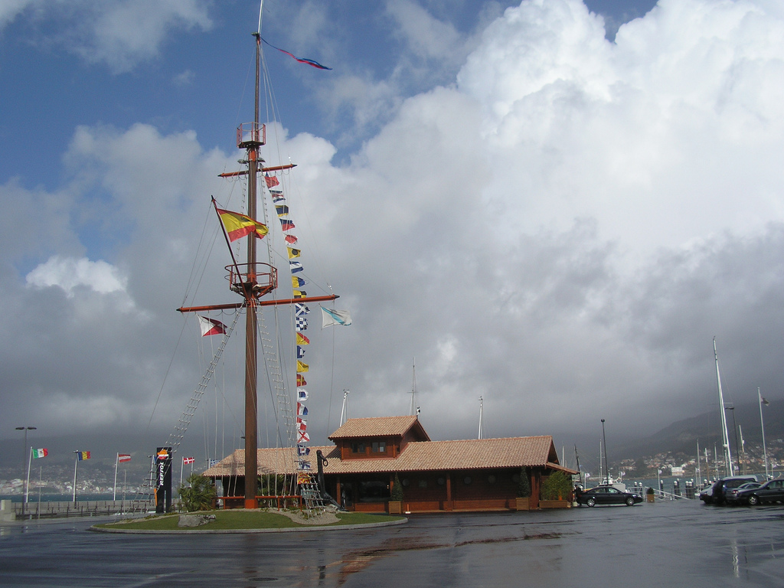



EUROSAF – EUROPEAN WOMEN MATCH RACING CHAMPIONSHIP

August 15-19, 2007

NOTICE OF RACE

1. Organising Authority

The Organising Authority (OA) is Royal Spanish Sailing Federation (R.F.E.V.) in conjunction with the EUROSAF, Club Náutico Punta Lagoa and Galician Sailing Federation..

2. Venue

The venue will be Club Nautico Punta Lagoa – Vigo, Galicia, Spain
.
3. Event Grading.

The event has applied for ISAF Grade 2
This grading is subject to review by the ISAF Match Race Advisory Board.
The event may be re–graded, when there is a clear reason to do so.

4. Provisional Programme

Schedule: Racing Days
(a) Race office is open on August 15th from 12.00 until 18.00
(b) Registration: on the Race Secretary on August 15 th from 12.00 until 18.00
(c) Crew weighting as in (a)
(d) Practice: on August 15th from 12.00 until 19.00
(e) First briefing August 15th at 19.30.
(f) First meeting with the umpires: following the first briefing.
(g) Opening Ceremony at 20.30
(h) Racing days: 16 to 19th of August 2007
(i) Time of the first race: 16.th August - Attention signal 10.00
(j) No attention signal will be given after 14.30 on the August 19th, unless especially
agreed upon at the latest on the skippers meeting ff August 19th
(k) Daily Press Conference: 25 minutes after finishing the last race of the day, if so
required
(l) Prize giving for the final skippers and crew: Immediately after the last race
Unless excused by the OA, attendance at the following is mandatory:
(a) Initial briefing for skippers.
(b) Daily briefing for skippers.
(c) Daily Press conferences if held.
(d) Prize giving for the 3 best skippers and crews

5. Skippers eligibility

(a) A maximum of 12 skippers will be invited. Only skippers invited by the OA will be
eligible to enter this event. A total of 9 foreign entries will be recognised in order of
ranking. The enclosed application form has to be at the CN Punta Lagoa Office before the 14th of June. The 3 highest ranked Spanish skippers from the ranking list will be invited.. The OA will inform the skippers invited at the latest on the 21st of June.
The OA has reserved 3wild cards that may be used for Spanish entries.
(b) So for the purpose of clarity, entrants will be accepted as follows:
i. 9 Foreign entries in ranking order
ii. 3 Spanish teams
i(c) The registered skipper shall helm the boat at all times while racing, except in an
emergency.
(d) To remain eligible a skipper shall confirm acceptance of invitation in writing, (fax or email
is acceptable) before the 24 of June 2007
(e) All competitors shall meet the eligibility requirements of ISAF regulation 19.2.
(f) All competitors shall obtain a ISAF Sailor ID by registering on line at:
www.sailing.org/isafsailor. Skippers shall inform the OA of their ISAF Sailor ID at
registration.

6. Entries

(a) The team shall be entered on completion of registration, crew weighting, and the
payment of all fees and deposits. Local Currency is preferred, credit cards will be
accepted. Foreign currency may be accepted, check with the OA.
(b) Entry Fee 500 €. The non refundable fee of shall be paid at paid at registration, unless
extended by the OA.
(c) Damage deposit.
I. An initial damage deposit of 300 € shall be paid at registration.
II. This deposit is the maximum payable by the skipper as a result of any one
incident.
III. In the event of deduction from the damage deposit is decided by the OA it may
required that the deposit must be restored to its original amount before the skipper
will be permitted to continue in the event.
IV. Any remaining deposit after the event will be refunded within 10 days after the
event.

7. Rules
a) The event will be governed by the "rules" as defined in the RRRS, and including
the Appendix C.
b) The rules of handling of boats will also apply to any practice sailing and sponsor
races.
c) Class rules will not apply.
d) The national authority prescriptions will not apply.

8. Boats and sails

(a) The event will be sailed in SUN FAST 2000
(b) 10 boats will be provided.
(c) The following sails will be provided for each boat: Mainsail, Genoa, and
Symmetrical Spinnaker.

9. Crew (including skipper)

(a) The number of crew (including the skipper) shall be 4.
(b) All registered crew shall sail all races.
(c) The maximum total crew weight is 275 kg, when wearing at least shorts and a
shirt.
(d) When a registered skipper is unable to continue in the event the OA may authorise
an original crewmember to substitute.
(e) When a registered crewmember is unable to continue in the event the OA may
authorise a substitute, a temporary substitute or other adjustment.

10. Event format

(a) The event will consist of the following stages: Round Robin, Semi-final and Final.
I. Round Robin: It is the Committees intention to sail a full RR where all competitors
have a chance to meet.
II. Semi Final: The 4 best from the RR:S sail a knockout series: first to score 2 points
wins. The winner of the Round Robin gets to choose his opponent.
III. Final: The winners of the Semi Final matches to sail for first place: First to score 2
points is winner. The losers of the semi-finals sail for 3rd place, the first to score 2
point is the winner.
(b) The OA may change the format, (terminate or eliminate any round, when conditions do
not permit the completion of the intended format.

11. Course
(a) The course will be windward/leeward with starboard rounding, finishing downwind.
(b) The course area will be on the waters close to Club Nautico Punta Lagoa , and is
shown on supplied chart given to the skippers at the initial briefing or the practice,
whichever comes first.

12. Advertising

(a) As boats and equipment will be supplied by the OA, Appendix 1, regulation 20.3.3
applies. Each boat will be required to display advertising as supplied by the OA.
(b) Competitors may be permitted to display advertising ashore at the venue, but this is
subject to individual negotiations with the OA.
(c) Boats shall not be permitted the right to protest for breaches of any rules regarding
advertising (amends RRS 60.1).

13. Prizes Money

- First 3000 EUR
- Second 2000
- Third 1500
- Fourth 1200
- Fifth 1000
- Sixth 900
- Séventh 800
- Eighth 700
- Ninth 600
- Tenth 600
- Eleventh 500
- Twelfth 500

14. Media, images and sound

The OA may require television personnel and equipment or dummies to be carried on
board while racing and may require competitors to be available for interviews. The OA
have the right to use images and sound recorded during the event free of any charge.

15. Disclaimer

All those taking part in the event, do so at their own risk. The OA, its associates and
appointees accept no responsibility for any loss, damage, injury or inconvenience
occurred, howsoever caused.

16. Invitations

Entries will only be accepted from invited skippers. If you wish to be invited, please
register your request for an invitation as soon as possible with the OA by completing
the attached form.

17. Possible changes

If there should be any changes in the NOR, these will not comprise changes of boats,
event schedule or area of racing, but can affect areas not directly affecting racing.

Additional information

Accommodation

The OA will cover accommodation from 15 to 19 August 2007. Dinner every day and lunch package will be free, as well.
.

Please send the application form to:

Club Náutico Punta Lagoa
A Lagoa, Teis, s/n
Vigo, Pontevedra
36207
Spain
Phone: +34986374305 fax: +34986410096
e-mail: comiteregatas@nauticopuntalagoa.com
web: www.nauticopuntalagoa.com


CLUB NÁUTICO PUNTA LAGOA
La Lagoa s/n Teis - 36207 Pontevedra, Spain
Tel. 34 986 37 43 05 - Fax +34-986 41 00 96
www.nauticopuntalagoa.com comiteregatas@nauticopuntalagoa.com

EUROPEAN WOMEN MATCH RACING CHAMPIONSHIP 2007

ACCEPTANCE OF INVITATION

Please fill in the following form and either fax or e-mail it to CN Punta Lagoa

HELMSMAN

Name and Surname
Nation
Ranking Position
Isaf Sailor ID
Address
Club
Telephone number

CREWS
Name and Surname |  | Nation | Club
DECLARATION
I agree to be bound to the I.S.A.F. and F.I.V. Rules, under which jurisdiction this regatta is sailed; to the Regatta Instructions and to the class Rules, I declare to undertake every responsibility on myself for damages to the persons and to my own or third parties things, at sea or ashore, in consequence of my participation in the regatta. In order to take part to the race I also declare to have all the physical requisites, as specified in the health certificate and to sail at my own risk taking upon myself all responsibility.
DATE | SIGNATURE
□I authorize payment of Euro 500,00 on my credit card:
Visa Master Card

Name of card owner: ___________________________

Card number: ___________________________

Expiry date: ___________________________

Signature: ___________________________
□I pay Euro 500,00 by bank transfer (free of expense for beneficiary) and I send you a copy here with. Punta Lagoa bank details: I.B..A.N. ES10-2091-0501-6130-4006-3496
BIC : CAGLESMMXXX

